Documentation
Thanks for downloading this asset pack! Visit our website for more free game development content and a biweekly podcast. There is also a YouTube video where all this documentation is explained.
YouTube Tutorial: https://www.youtube.com/watch?v=yC9qaW_RqBU&feature=youtu.be
Website: https://moonlightgamedevs.com
Support Email: moonlightgamedevs@gmail.com

Table of Contents
Overview 2
Project Setup 2
Overriding the Input Settings of your Project 2
Adding the necessary Input Settings to your Project 3
Scene Setup 3
Creating a new Weapon Prefab 3
Basic Prefab Structure 3
Mesh Configuration 4
Animation Configuration 4
Configuring the Weapon Scripts 6
Base Stats 6
Swing Directions 6
Animation Curves 7
Quick Swing 8
Charge Stats 9
Adding the Weapon to the Player Inventory 9
Parrying 10
Custom Systems 10
Stamina 10
DamageInfo 10
Proprietary Systems 10
Free 3D Models 11

Overview
This asset pack is designed to offer a foundational combat system for melee first person battle, inspired by the likes of Dark Messiah or Pirates Vikings Knights 2. It contains:
- Modular system for creating new melee weapons
  - Supports multiple swing directions, each swing direction has their own stats that can be customised
  - Timed “perfect strikes” that adjust to the animations
  - Charged versus quick attacks
  - Parry enemy attacks
- Three high quality 3D weapon models
- Basic GUI Elements to give player feedback on elements like their health, stamina, etc.
- Proprietary unity assets from the first person tutorial, that are integrated with the system

Project Setup
To use the scripts, you need to configure the input correctly. The first person melee combat system is built upon the input handler provided in the Unity first person microgame tutorial (download in the Unity Hub and provided in the overview above). There are two simple ways to configure them.

Overriding the Input Settings of your Project
Disclaimer: this method will override any input configurations that you have made!
Included in the asset pack is a file called “InputManager.asset”. Copy this file and navigate to the ProjectSettings folder in your game project. There, you will see a file with the same name. You need to delete it and replace it with the file from the asset pack.
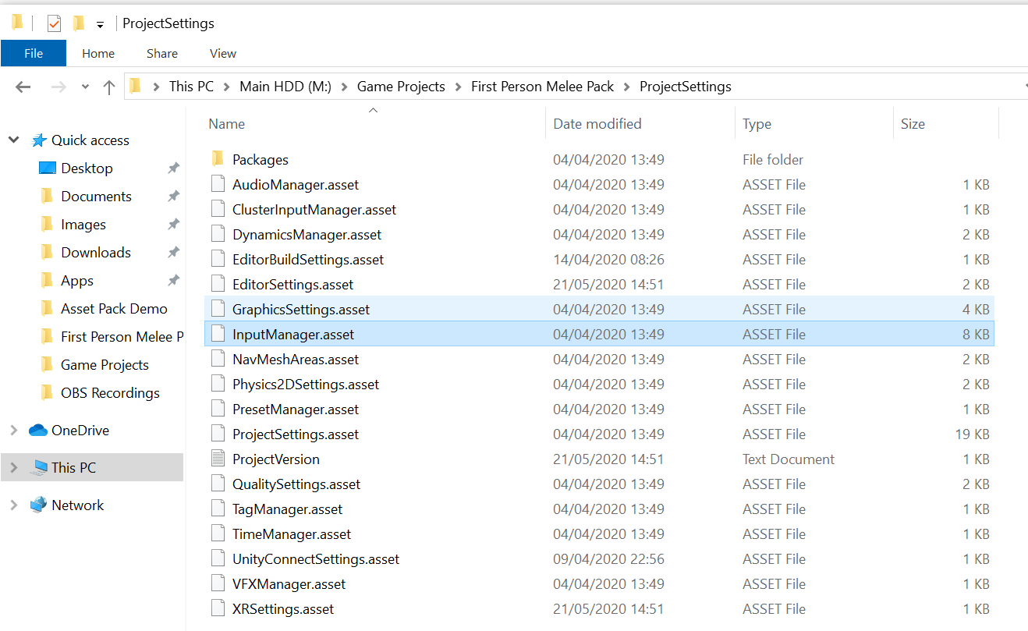

Adding the necessary Input Settings to your Project
Navigate to the scripts folder of the asset pack and open a file called “GameConstants.cs”. In there, you will find a list of string type variables that correspond to the names of inputs in the project settings (these are used in the code to determine key and gamepad presses). You need to find what inputs do not correlate and add them (or change the constants in the code)! To do so, go to the Unity Editor and navigate to Edit > Project Settings, where you can configure them as needed.
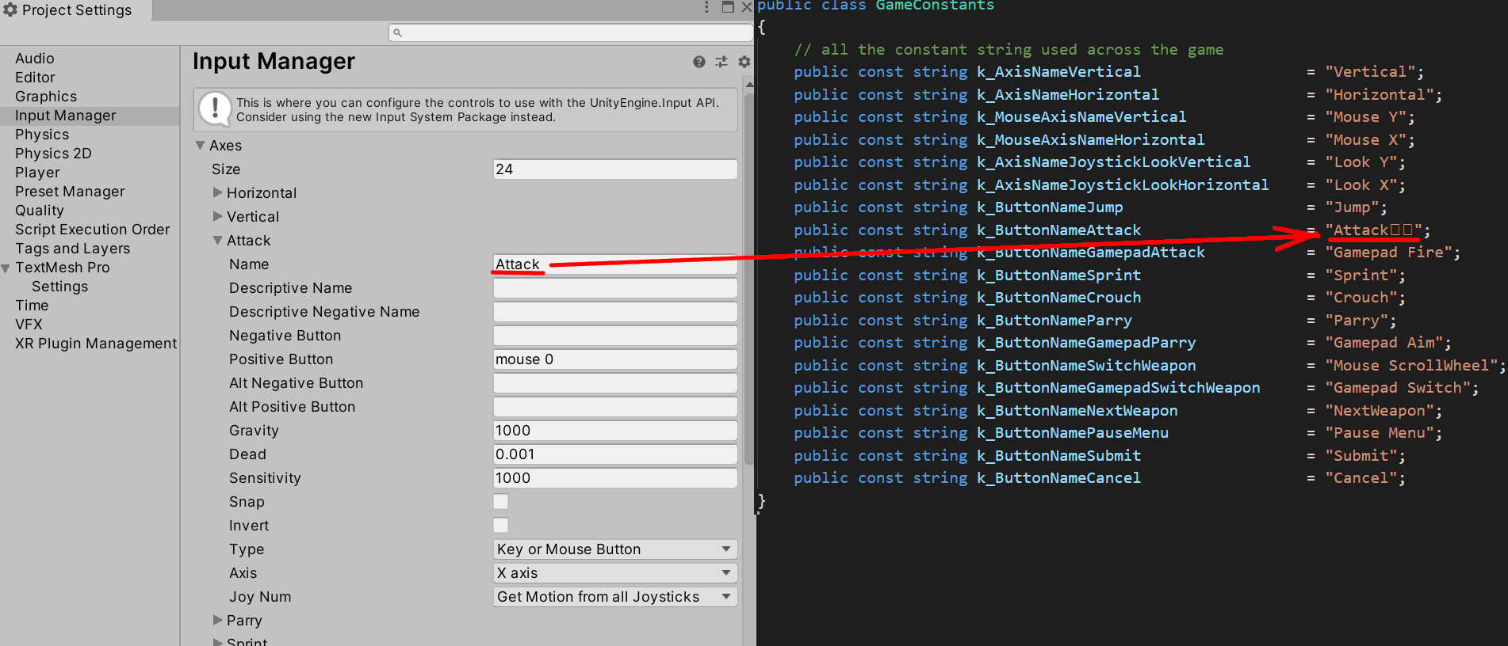

Scene Setup
Create a new scene. Delete the default camera and drag in the player prefab (Prefabs > Characters) into the level, drag out a plane that acts as the floor and add the Game HUD (Prefabs > UI). You should now be able to move around the world with some basic graphical indicators.
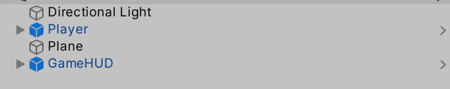

Creating a new Weapon Prefab

Basic Prefab Structure
We want a parent object (called “HammerWeapon” in this example) that is going to hold all of our scripts (I will get into what does are later on). I’m going to be adding a “Root” component as a child of that object, but its not necessary. I’m merely doing this because the asset I am going to be using is static and I thought that I could potentially apply some transformations to the child object which holds the actual mesh and animator. Here is the layout of my prefab:
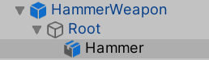

Mesh Configuration
The game object which is called “Hammer” in our example holds the mesh renderer and animator. I am just going to be using one of the meshes that ships with the asset pack. Make sure you add a weapon animator (found under the “Animations” folder in the asset pack) as well. I’ll be showing you how to configure that in the next section.
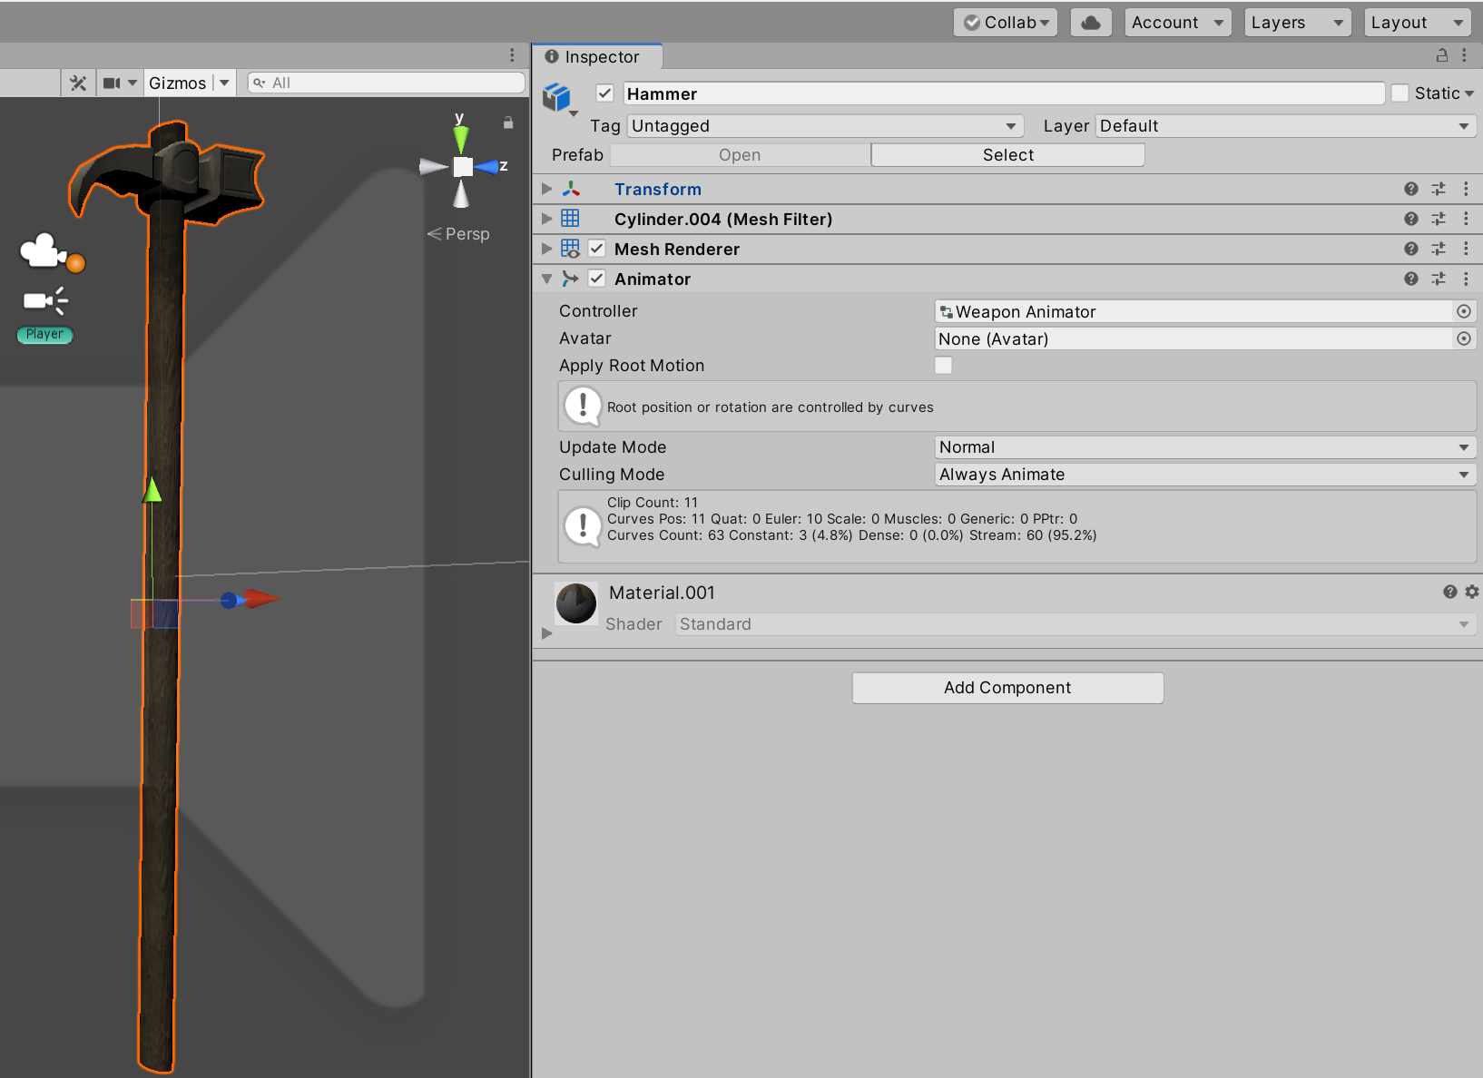

Animation Configuration
The animator is essential to making this system work! In the asset pack, you will find an animator called “WeaponAnimator” under “Animations” folder. The system relies heavily on the parameters and state names here, so only change these with cautions. There is also really no reason to unless you want to extend it, because you are never going to need to manually configure any of these parameters as they are set in the code and configured using variables that you can change in the Unity editor.
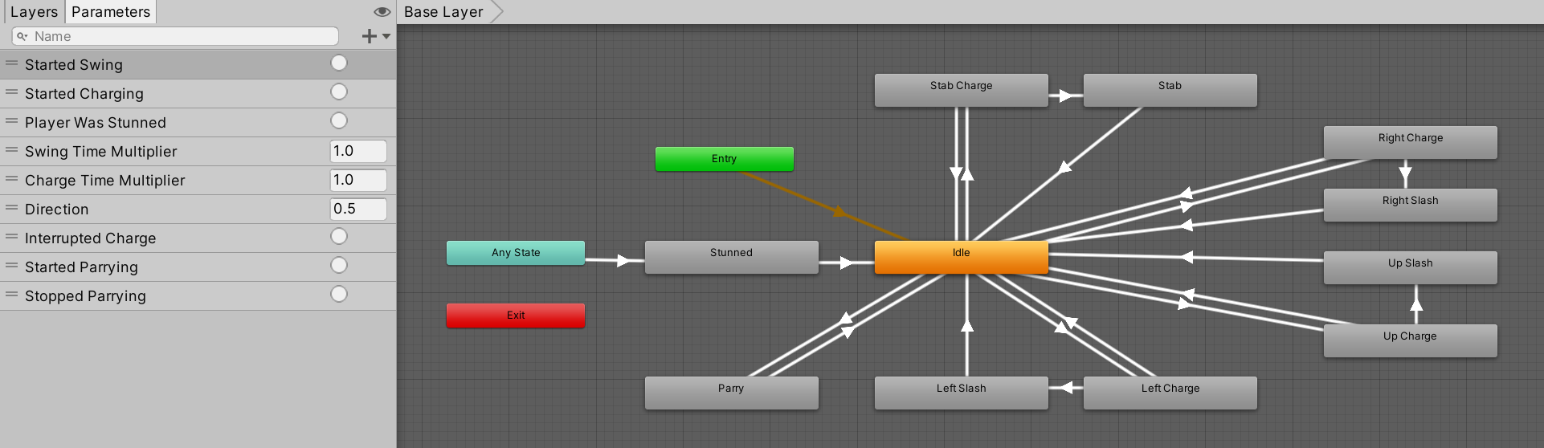
To customise this for our own weapon, we need to override this animator. Right click somewhere in the file browser and create a new Animator Controller Override.
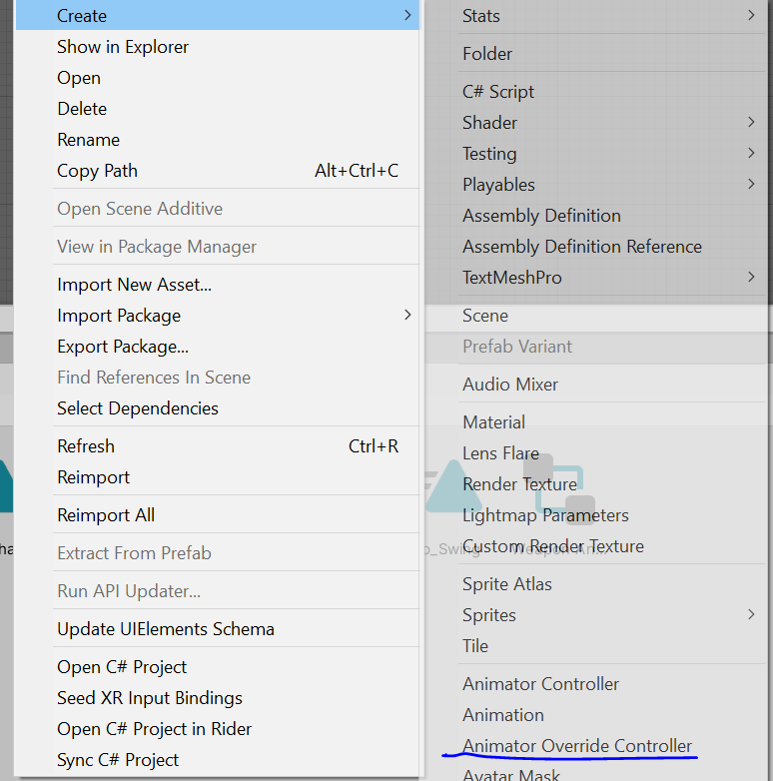
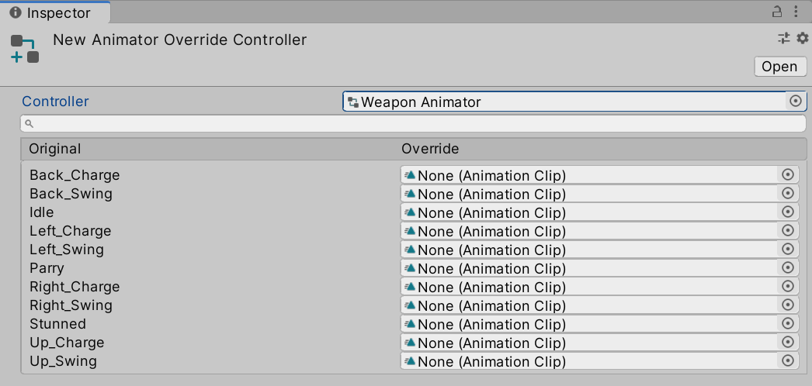
For our new animator override, we are going to select the weapon animator as the controller and then simply assign the animations that correspond. That way, you can use any weapon asset provided that you have the right animations with this system and have it work out of the box.

Configuring the Weapon Scripts
The weapon functionality consists of three scripts, one of which is optional (the parrying script). By searching for and adding a “MeleeWeapon” component to our prefab, we automatically see that a “WeaponAnimatorDirectionUpdate” component has been added as well. The latter is a script that automatically updates the direction parameter in the animator, so we don’t have to worry about it at all.
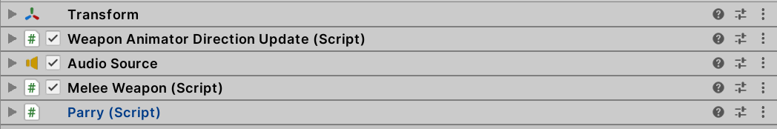
The MeleeWeapon component defines the base behaviour for our weapon, containing several attributes that we can use to customise it. We want to start by assigning the animator that we have attached to our mesh and the weapon root (only used to toggle weapon visibility for item switching).
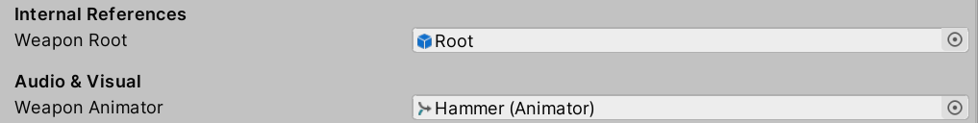
Aside from that, we have several aspects that we should focus on customising.

Base Stats
We can define base stats (which are hopefully fairly self explanatory) for our weapon like the points of damage it deals, the speed of the attack or how fast we can charge our weapon so that it deals more damage. The system automatically speeds or slows down animations accordingly, so the changes correlate visually. This includes charging the weapon, so your weapon is fully charged i.e. deals maximum damage on swinging when the animation has finished.
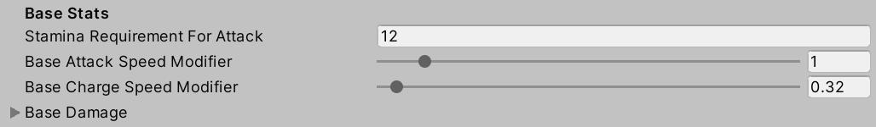

Swing Directions
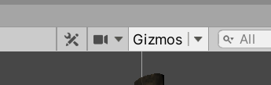
One of the key features is that the weapons attack in different directions, depending on the movement input of the player (i.e. if the player is moving right, their attack will go from right to left). This works using RayCast, so I suggest activating Gizmos to get a better understanding of how this works in-game.
Each attack direction can be further customised within the editor. To do so, we need to create a new scriptable object of the type “SwingStats”, which you can do by just right clicking in the file navigator. There are a bunch of variables with the word “Mod” in them.
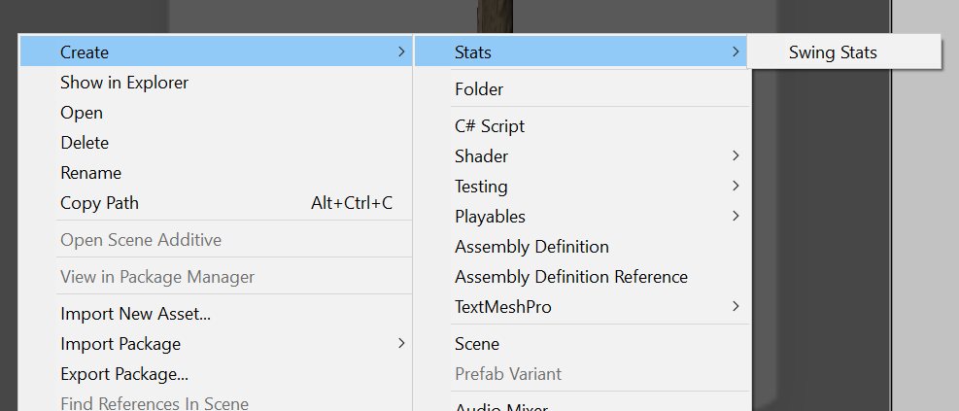
Make sure that you assign them at the bottom of your weapon melee script, because you will experience some unwanted behaviour otherwise. Here is an example where I made swing stats for a horizontal and vertical swing.
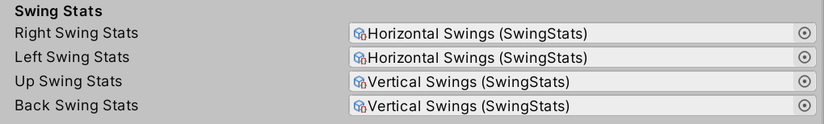
We have a variety of values we can customize. The “Mod” variables are added to the corresponding stats in the weapons base stats, but only when this particular type of swing is being executed. For example, if I assigned a Swing Stats object for when the player swings right to left and have a value 1 for the “Damage Mod”, with 12 as the base damage for the weapon, the final damage dealt when successfully hitting the enemy whilst swinging right to left is 13.

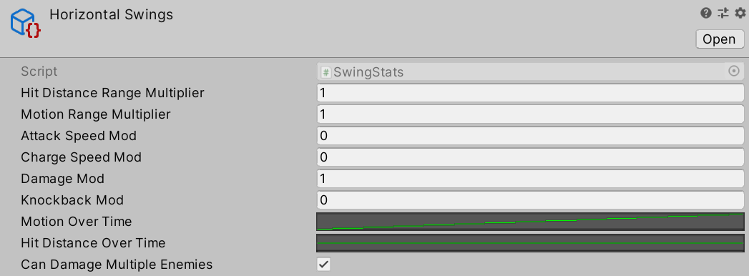
Animation Curves
We also have the options, using animation curves, to control the motion of the swing over time, the distance of the attack, etc. Important is that you keep both the x and y values between 0 and 1 (since these are the values that the code assumes). Lets start by discussing the motion over time curve. When the player makes a swing in a particular direction, this value controls how far away from the centre of the camera the attack will sway at a given point of the animation (the curve, just like everything else, will adjust based on the animation play speed). 0.5 on the y axis indicates the point when the attack will be right at the centre of the camera. Here is an example: if I were to perform a swing attack from right to left, then if I am at a point in the curve where the y value is 0.7, my attack will be slightly left of the camera’s centre. This value is then multiplied by the “Motion Range Multiplier”, which controls the general breadth of attack (for example a broad sword would have a wider range of motion than a short sword), to calculate the final position of where the attack ray will be sent out from. The distance over time works in a similar manner, except that 0.5 on the y plays no special role here and it just reads in the current point on the curve multiplied by the “Hit Distance Range Multiplier” value.
When assigning a new curve for these, I suggest having a straight upwards curve for the “Motion Over Time” and a flat line default for the “Hit Distance Over Time”, from there you can adjust it as you need to.
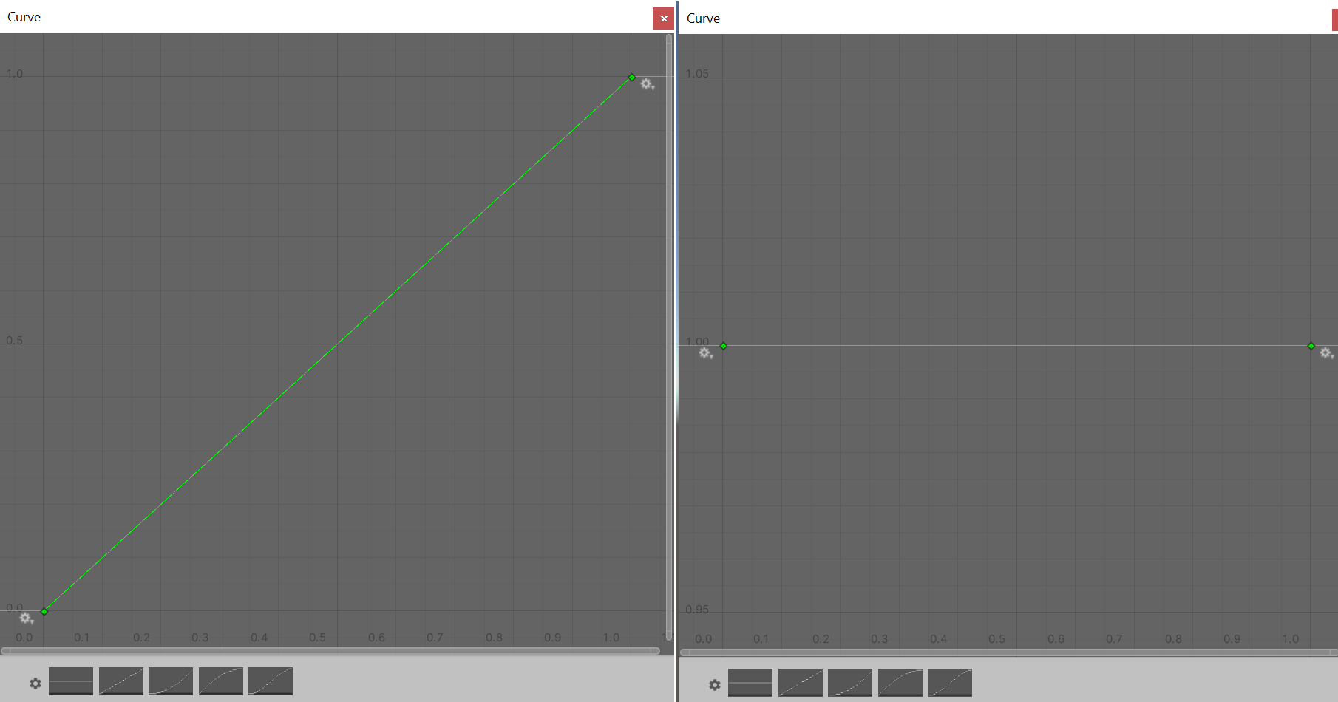

Quick Swing
Quick swings are executed when the player releases the mouse button before the transition between the idle animation and charging animation has finished, or the charge animation was playing for less than a given constant in seconds, which you can find as a constant in the code for file “MeleeWeapon.cs”.
There are multiple variables in the editor that let you define how the attacks behave when a quick swing is executed instead of a normal attack. They all work similar to those for the swing stats. Remember: quick swing damage modifiers are still ADDED, so if you want quick swings to for example deal LESS damage (which makes sense for most weapons) then you should make sure to give them a negative vale.

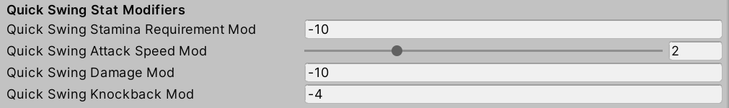
Charge Stats
Charging your weapon allows you to deal extra damage. The charge stats let you define by how much using the “Max Charge Damage” variable. It defines the extra damage dealt when the weapon is fully charged, if the attack is released sooner the extra damage is calculated by determining how far its charged and multiplying the maximum extra charge damage by that percentile. In other words, if the maximum extra charge damage is 12 and the bar is released while it is half full, the extra damage dealt is 6.
Another feature is the idea of a “perfect swing”, allowing the player to deal extra damage if they time their charge to be within the indicator bar that appears.
You can define the size of the bar (the value is in relation to 1, so for example a value of 0.5 is going to take up half the bar) and the offset (where the bar is positioned, so for example a bar placed at offset 0.5 starts at half the total charge bar).

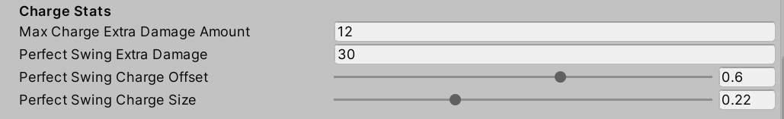
Adding the Weapon to the Player Inventory
Attached the player prefab, you will find a script called “WeaponManager”. If you look at the variables, you will find a “Starting Weapons” list variable. Set the size to whatever you want and drag the prefab in. Your weapon should now show up when you start the game.
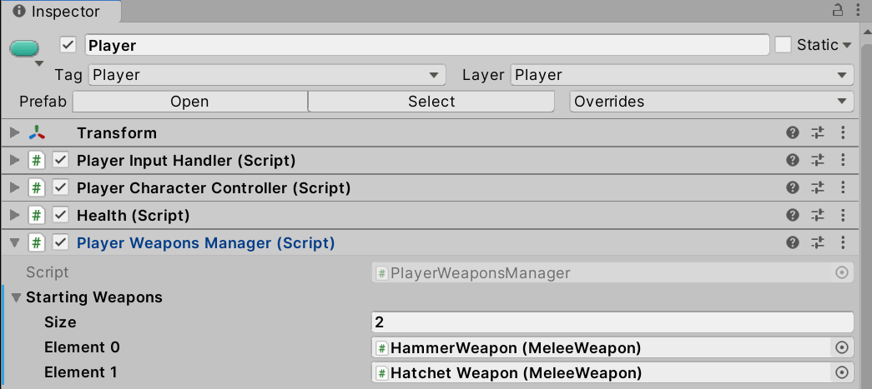

Parrying
To parry attacks, you need to add the “Parry” component script to the weapon prefab. This will allow you to block attacks coming from a frontal direction, provided your characters current stamina exceeds the required amount.

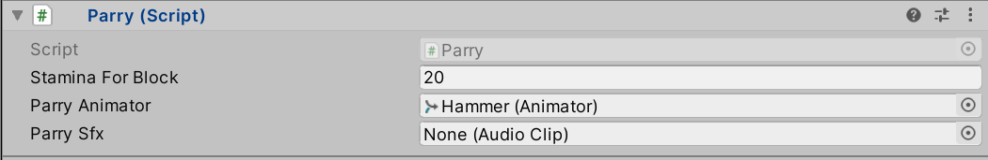
Custom Systems

Stamina
A “Stamina” component needs to be attached to the player for this system to work. Stamina is designed to reduce how quickly the player can execute certain actions consecutively and is integrated with player movement, as well as the melee weapon actions like attacking or parrying. You can ignore this restraint by setting all variables that have the name “Stamina Requirement” or similar to 0.

DamageInfo
To allow for more customisation of how damage is dealt to characters, the “DamageInfo” struct )(found under Scripts > StatsAndManipulation > DamageInfo.cs) was created. It is used in the weapon scripts, to pass on additional information when dealing damage. For example, it also contains information on how much force should be applied to the hit character, when they are dealt damage by this source (knockback) or if this is a blockable attack. This seemed a useful extension for the type of games that would utilise a system like this.

Proprietary Systems
The asset pack contains a lot of other systems, like weapon switching, health (the stamina system introduced is almost identical to the health system) or AI state machines. Most of this is derived and only slightly modified or extended from the Unity First Person template. Please check out the guide to get better insights into how these work than I could give here.

Free 3D Models
The asset pack includes three 3D models, use in any way you like.
